Prehistoric Species Index
Use this index to find information about the different organism for your geologic timeline. Circle the Era or Period in which the organism lived. Put a star next to the unique characteristics of their species. Underline why the species is important in relation to the evolution of life on Earth.
Keep in mind; this index has the organisms listed alphabetically. You are going to put them in order of when they appeared on Earth on your timeline.

Archaeopteryx
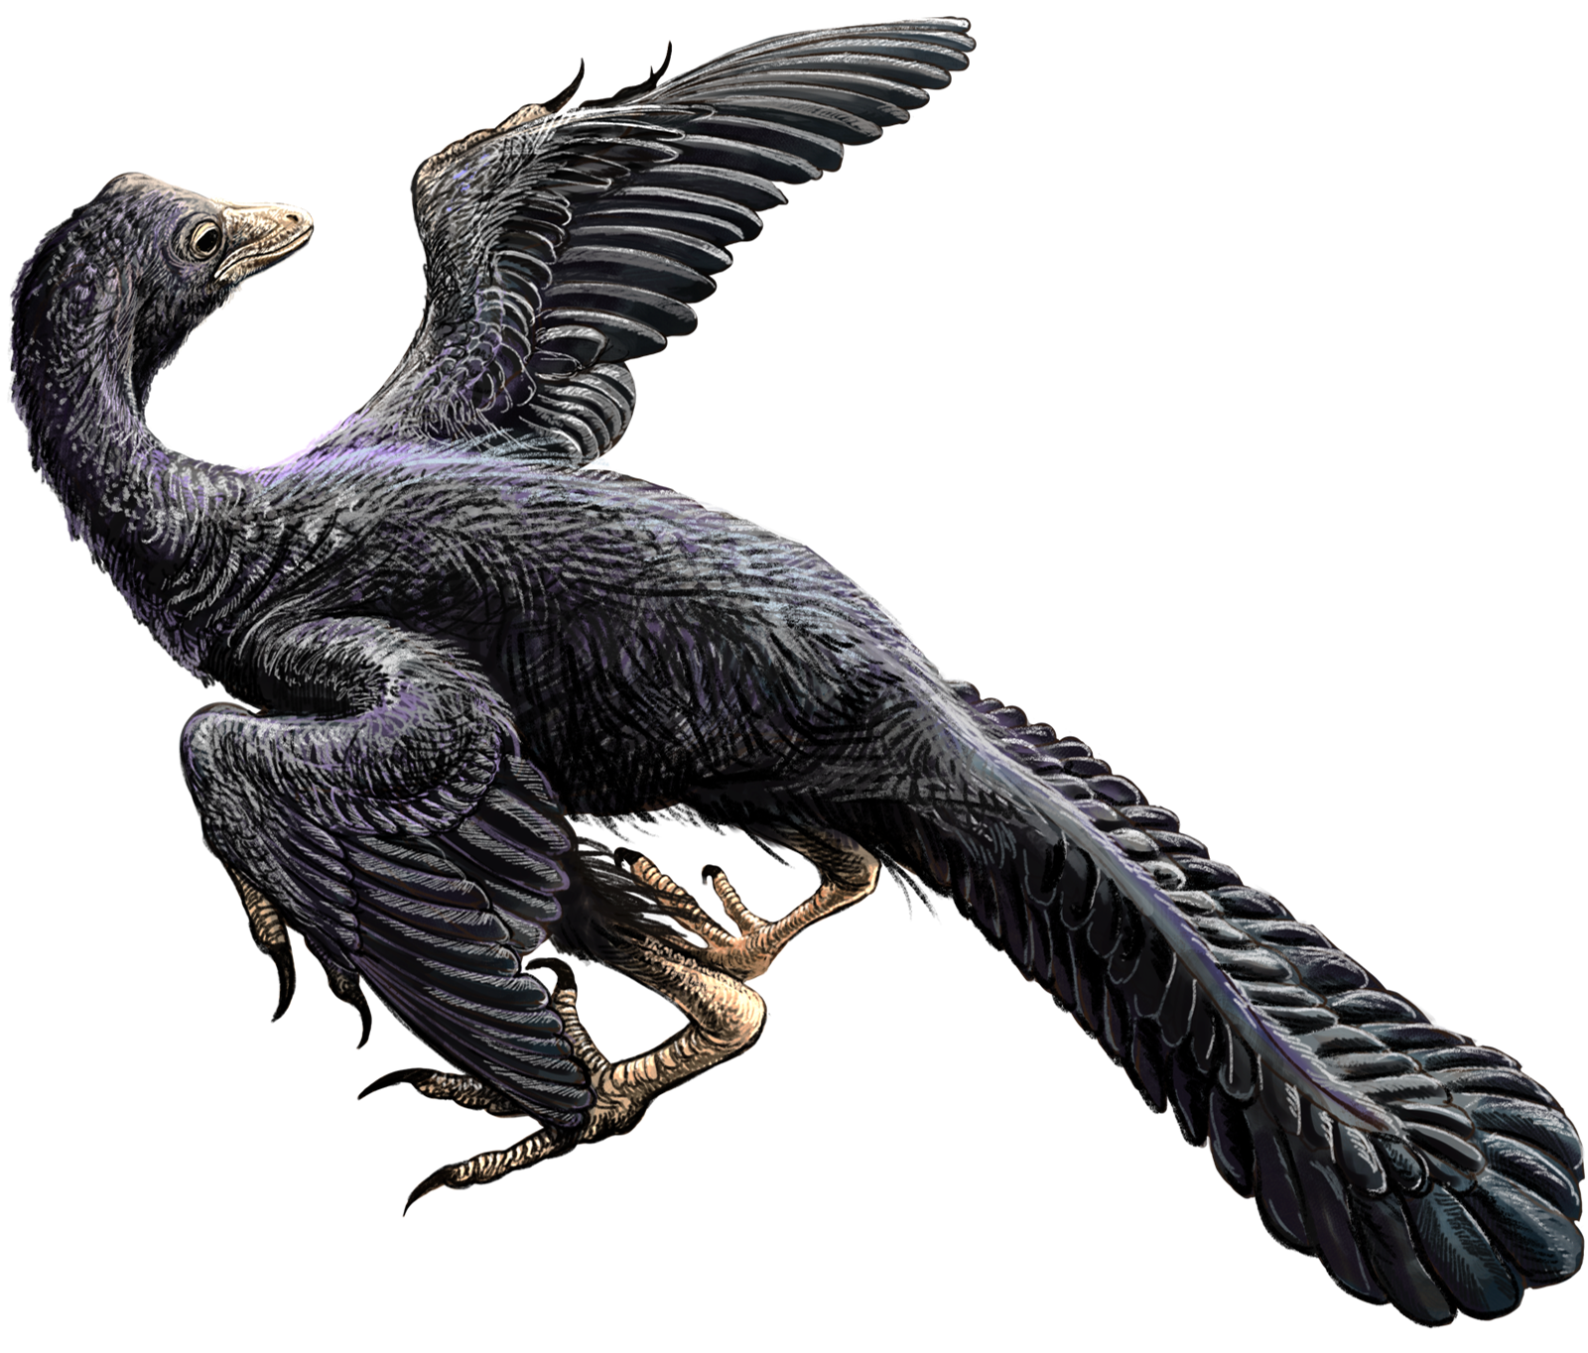
  - DataBase Center for Life Science (DBCLS)
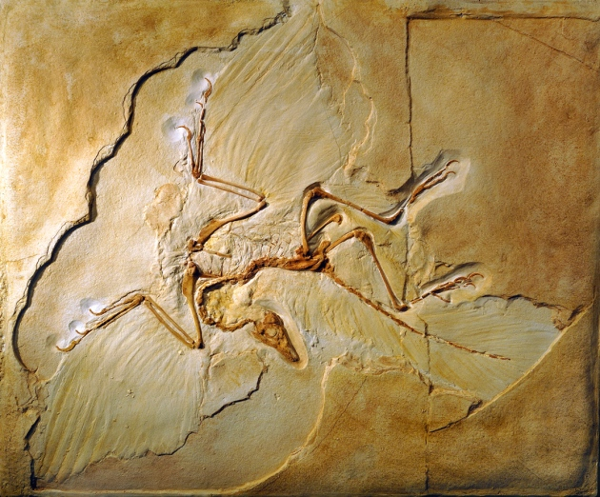
  - Tylwyth Eldar
Archaeopteryx lived around 150 million years ago in the Late Jurassic. A number of blue jay to chicken sized specimens have been found. Scientists realized that archaeopteryx provided a transitional link between dinosaurs and birds in the evolutionary tree. Archaeopteryx has traits similar to both dinosaurs and modern birds. Like a dinosaur it has a bony tail, teeth lining its jaws, and three clawed fingers. And like a bird, it has feathers covering its body and wings. Even though archaeopteryx has wings, some paleontologists cannot agree if it could fly or only glided.

Arsinoitherium
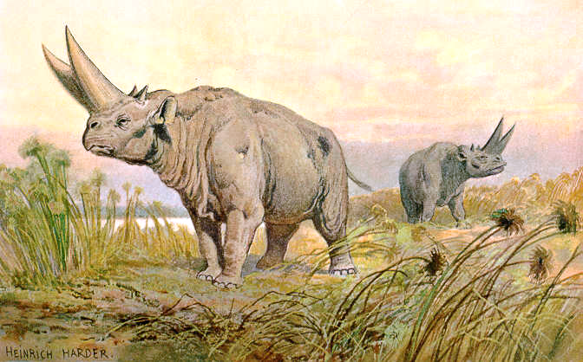
  - Heinrich Harder (1858-1935)
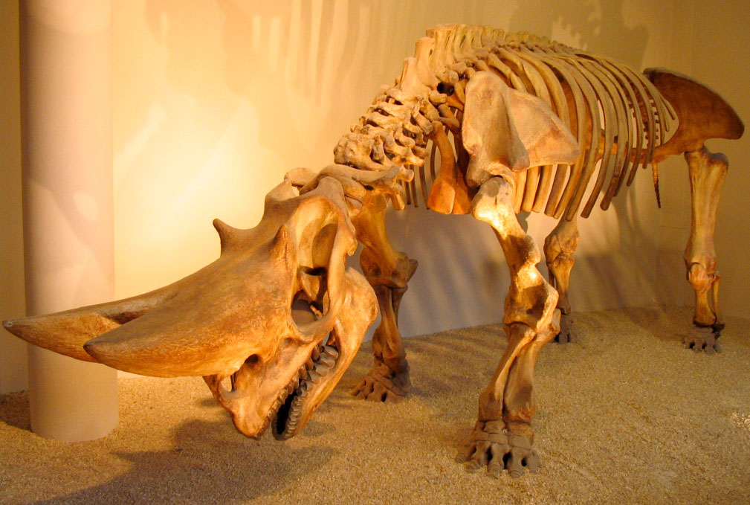
  - Aram Dulyan
This massive rhinoceros-like mammal lived in the Late Oligocene between 34 million and 23 million years ago. Its large horns were made of bone unlike a modern rhino whose horns are made of compressed hair. The teeth show that this swamp-dwelling animal mostly ate leaves. Paleontologists believe that arsinotherium is a distant relative to elephants and their relatives (known as probuscideans).

Cooksonia
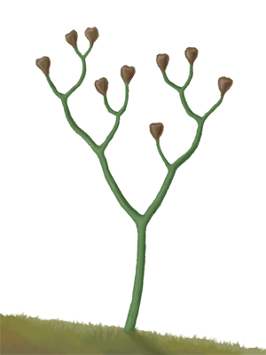
  - Ville Koistinen
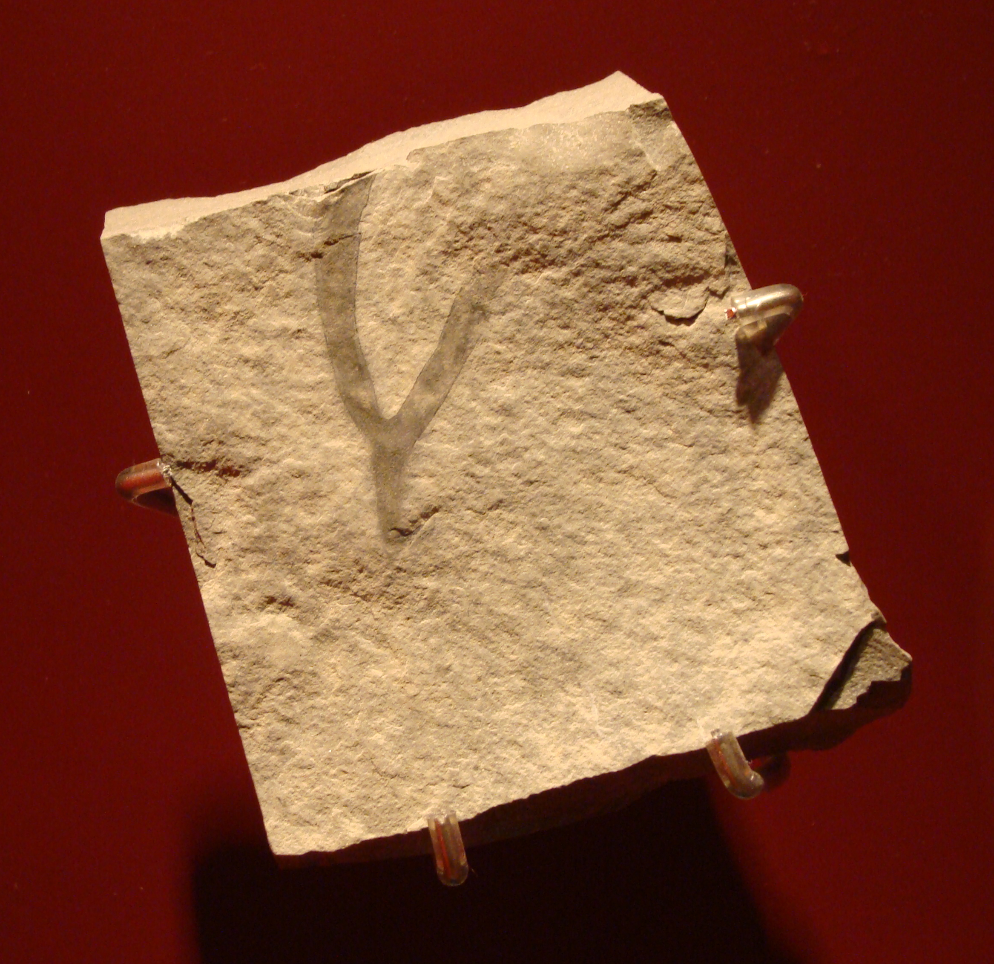
  - Eduard Solà
Cooksonia was a very early land plant and represents an important part of plant evolution. This is one of the first plants to develop vessels in its stem to transport water and nutrients through the rest of the plant. Cooksonia lived in swampy areas from the Silurian to Devonian Period. While it did not have leaves, it did release spores from special cases on the ends of its stem. A system of roots helped secure it to the ground while it grew.

Dimetrodon
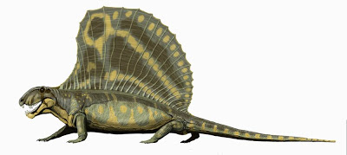
  - DiBgd at English Wikipedia
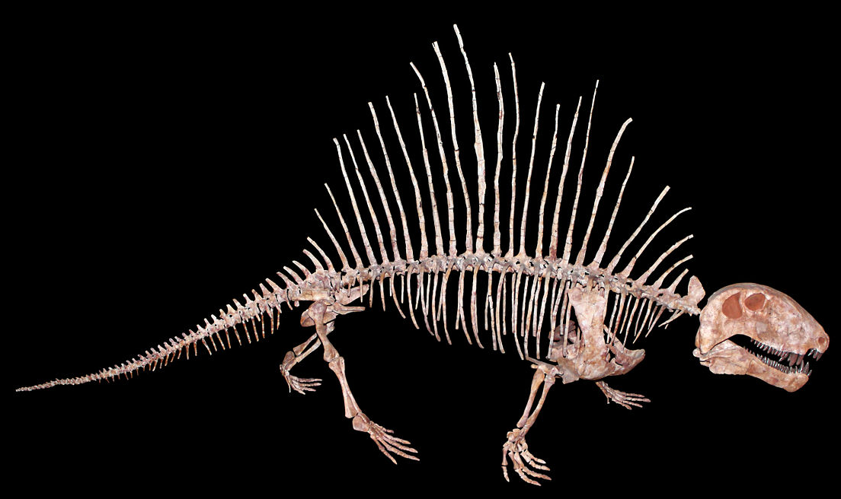
  - H. Zell
Dimetrodon is a unique mammal-like reptile from the Early Permian Period about 286 million years ago. Its knife-like teeth show that it was a carnivore with a long and narrow skull and eyes pointing forward. The large sail on its back was likely used for regulating its body temperature. Dimetrodon was not a true reptile and was likely related to the therapsids, a group that would eventually lead to mammals.

Ginkgo
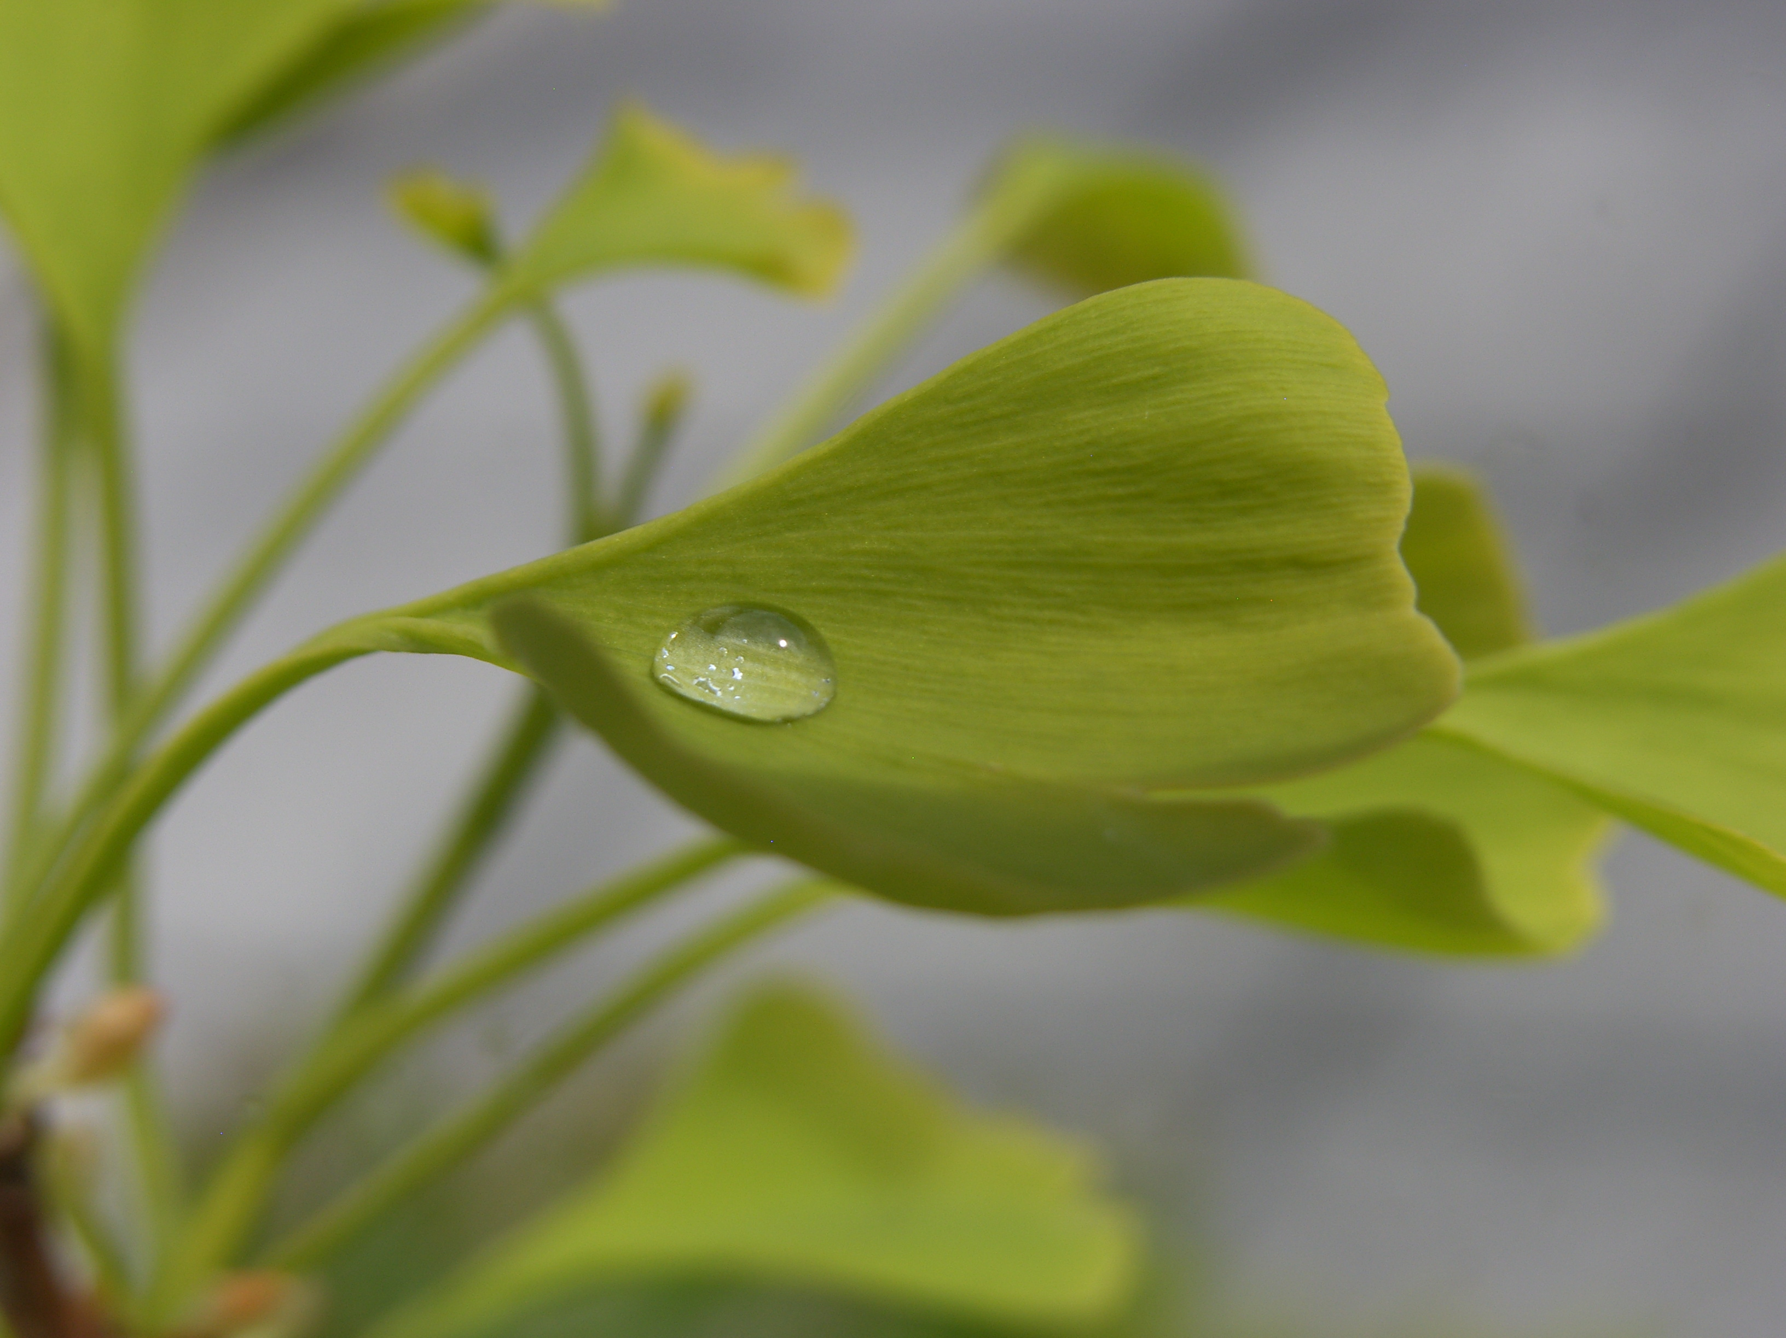
  - Wiki Commons User: Polymerix
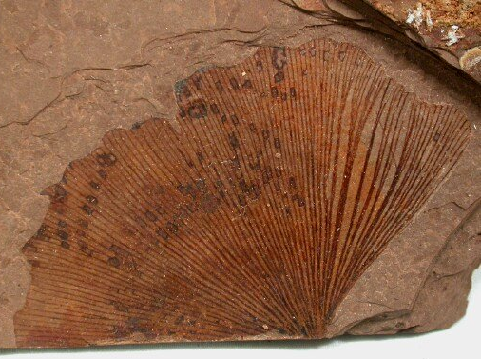
  - WikiUser: tangopaso (transfer to Commons)
Ginko trees first emerged in the Permian Period and are still growing in China today in the Quaternary. Paleontologists have found that they haven’t changed in 150 million years. Because of this the ginko is called a “living fossil”. Ginko trees actually have male and female trees that grow separately. Pollen is formed on catkins by male trees. It is then blown to female trees by wind so that they can grow seeds.

Homo sapiens
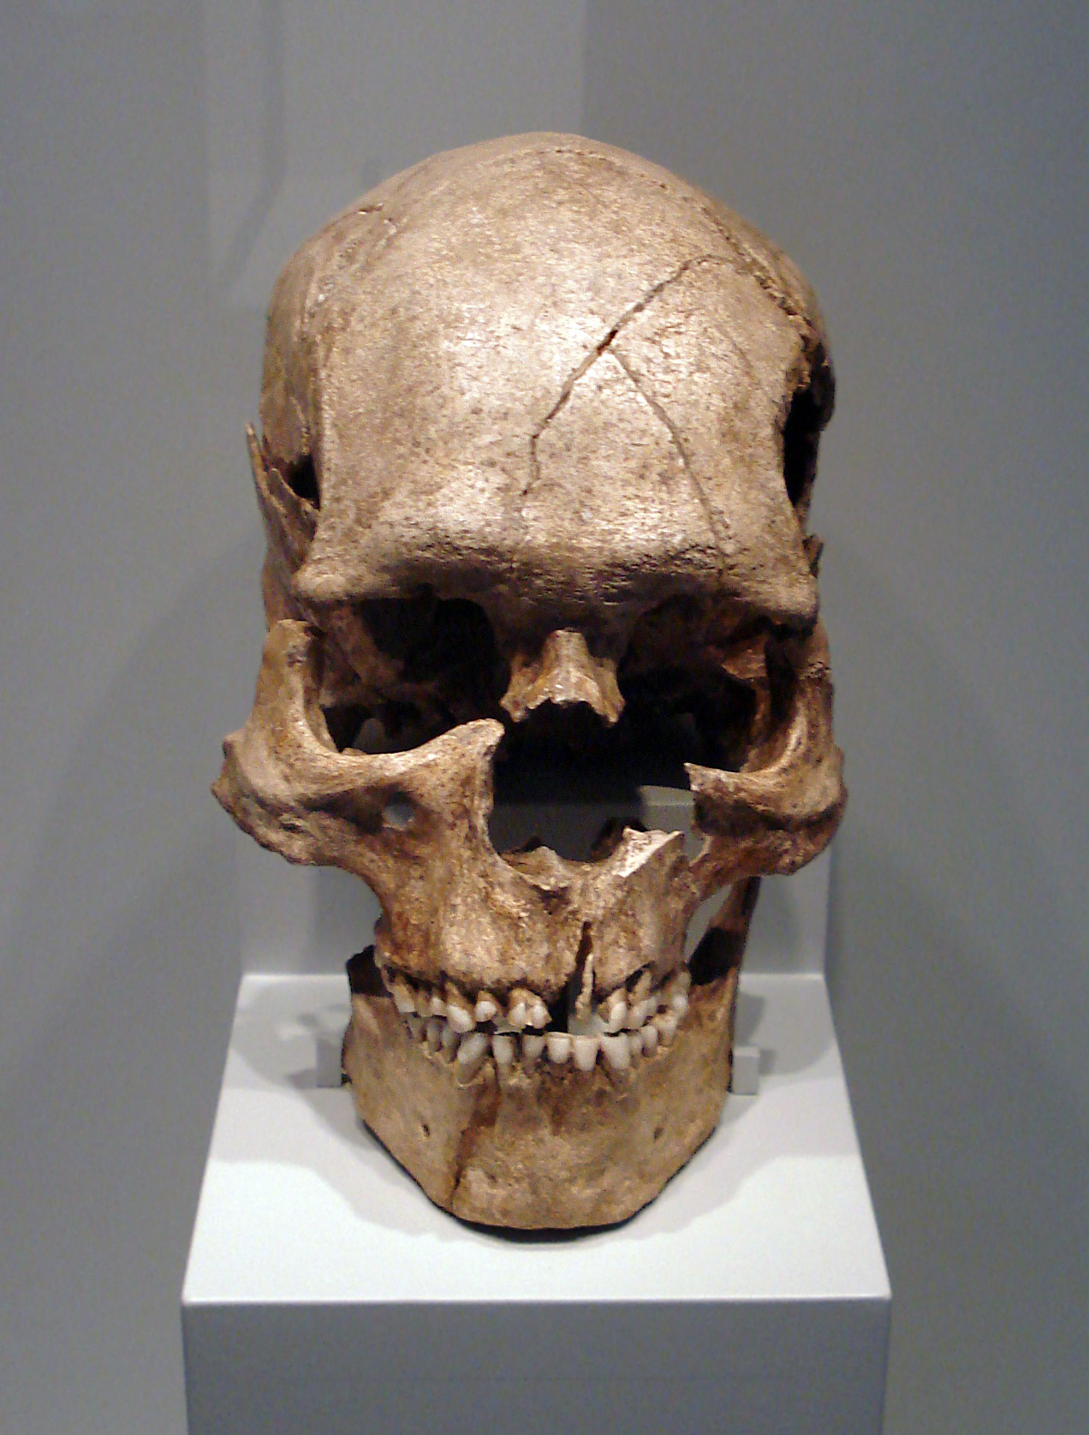
  - Dr. Günter Bechly
Homo sapiens is the species name of modern humans living now in the Quaternary. The earliest remains of modern humans are about 315,000 years old. Homo sapiens are well known for walking upright and using tools. In the past, Homo sapiens lived along side their relatives, the Neanderthals, who have since died out. Homo sapiens is characterized by a domed head, prominent chin, and a lighter built skeleton when compared to Neanderthals.

Mammuthus
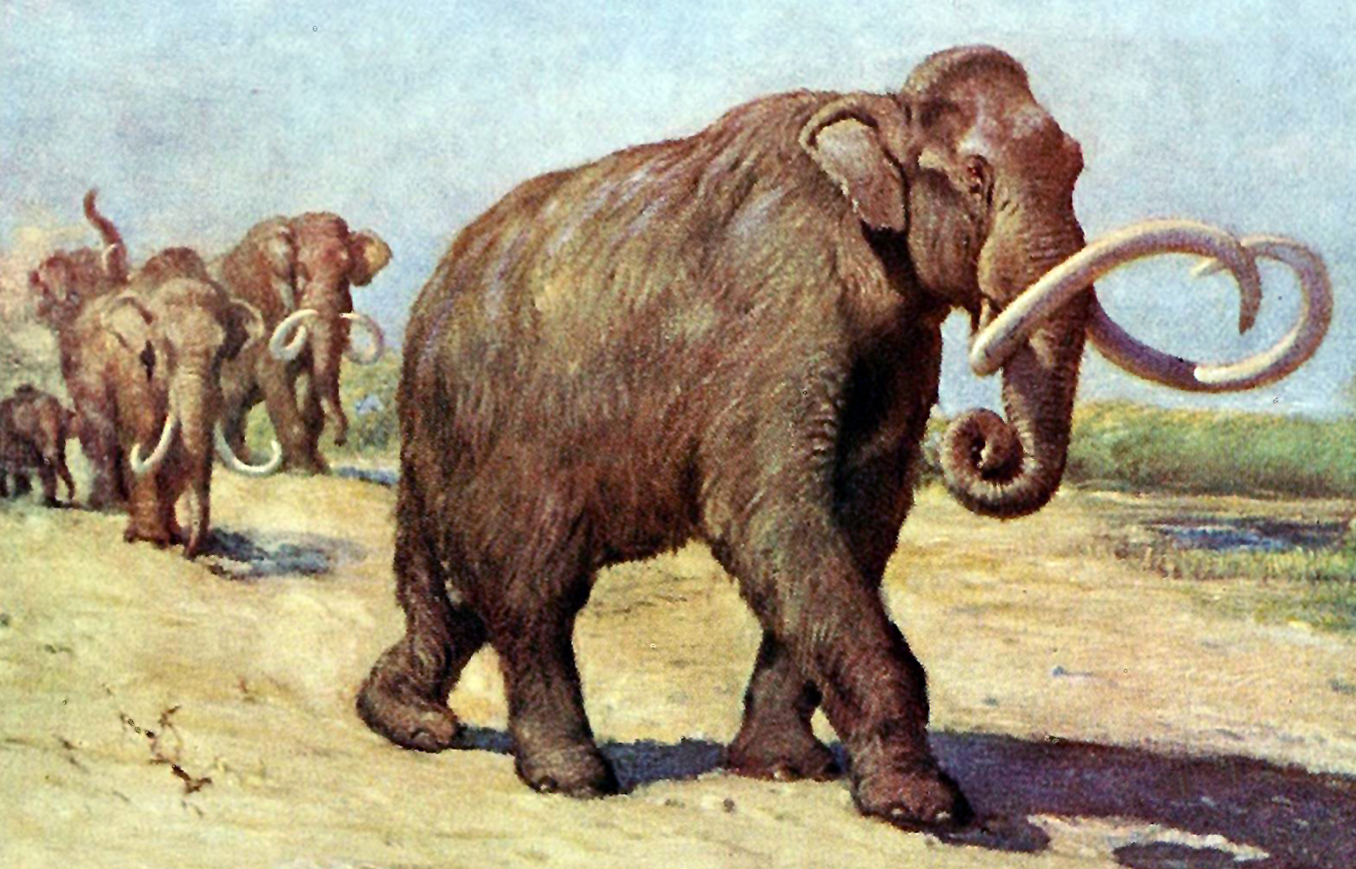
  - Charles R. Knight
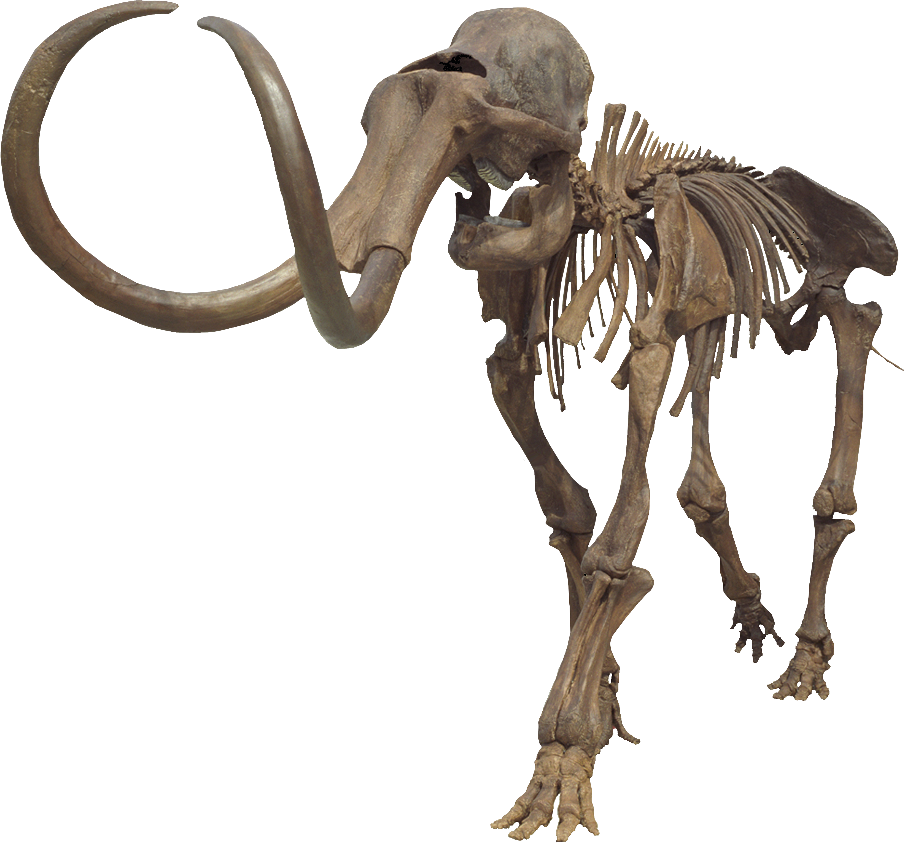
  - Wiki Commons User: MCDinosaurhunter
The most famous of the mammoths are the wooly mammoths with shaggy coats to live in the cold climate of the Ice Age. They lived from the Pliestocene into the Holocene Epoch. The last mammoths are believed to have gone extinct around 4,000 years ago. Most mammoths were about the same size as their modern day relative, the elephant. Their teeth were made up of a series of plates. These were worn down by constant grinding as the mammoth chewed the plants that made up its diet.

Morganucodon
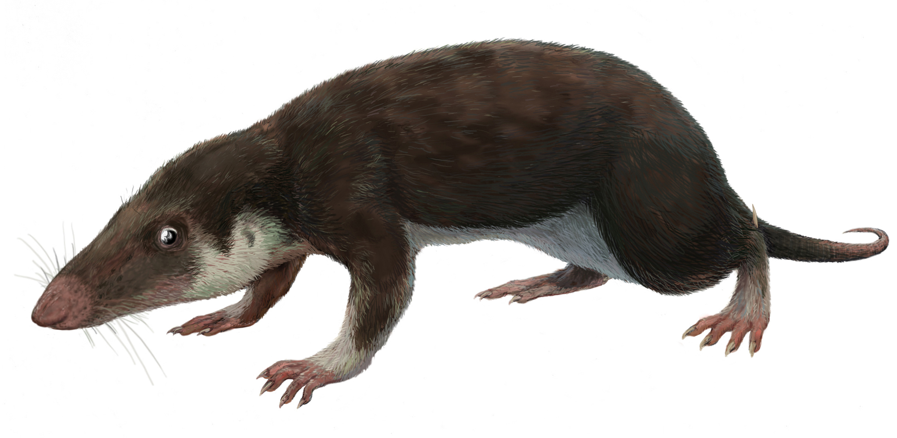
  - Wiki Commons User: FunkMonk (Michael B. H.)
Morganucodon was one of the first true mammals to appear on Earth around 200 million years ago. Most specimens are from between the Late Triassic and Early Jurassic Periods. Morganucodon was a small rat-like creature covered with fur. Its lower jaw was made of one bone and had distinct molars. It likely had sensitive hearing.

Neusticosaurus
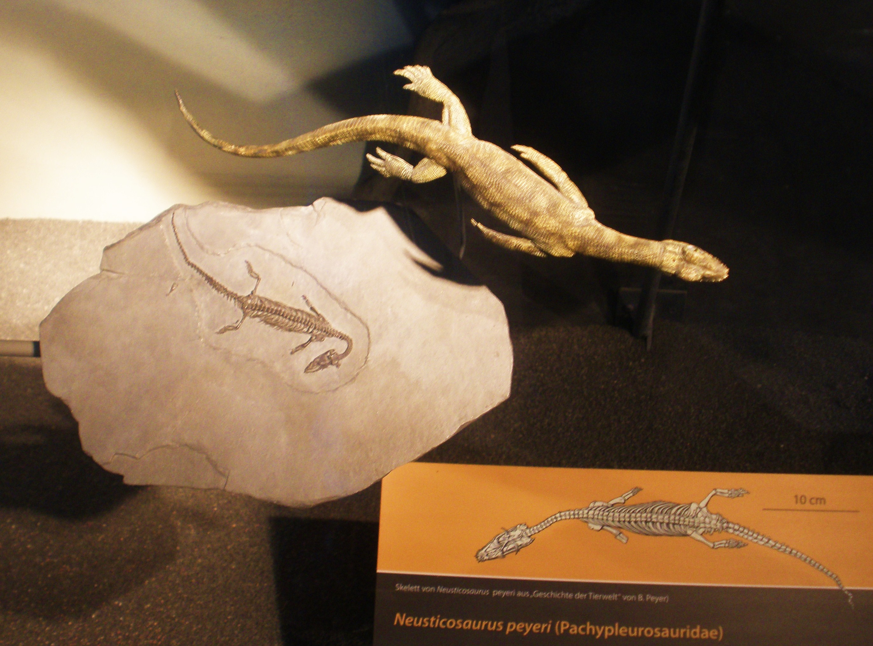
  - Wiki Commons User: Ghedoghedo
Neusticosaurus was a small marine reptile from the Middle Triassic Period. It was one of the earliest reptiles to adapt to life in the water. Some of these adaptations include a streamlined body, an elongated neck, and a small head. Neusticosaurus most likely fed on small fish as it swam.

Orthoceras
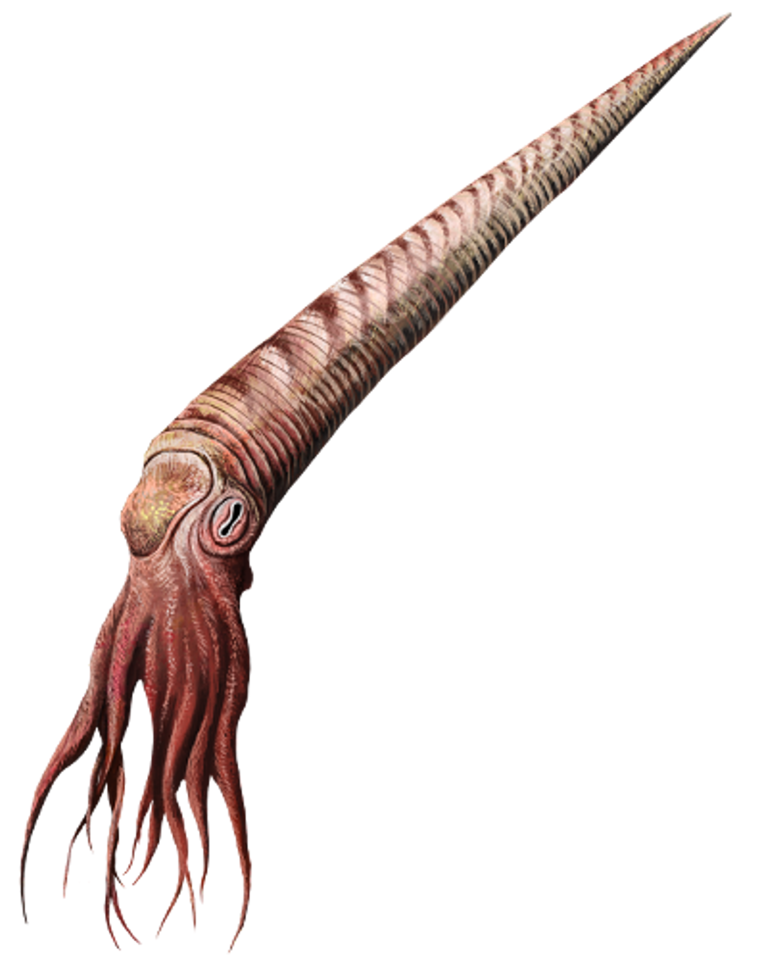
  - DataBase Center for Life Science (DBCLS)
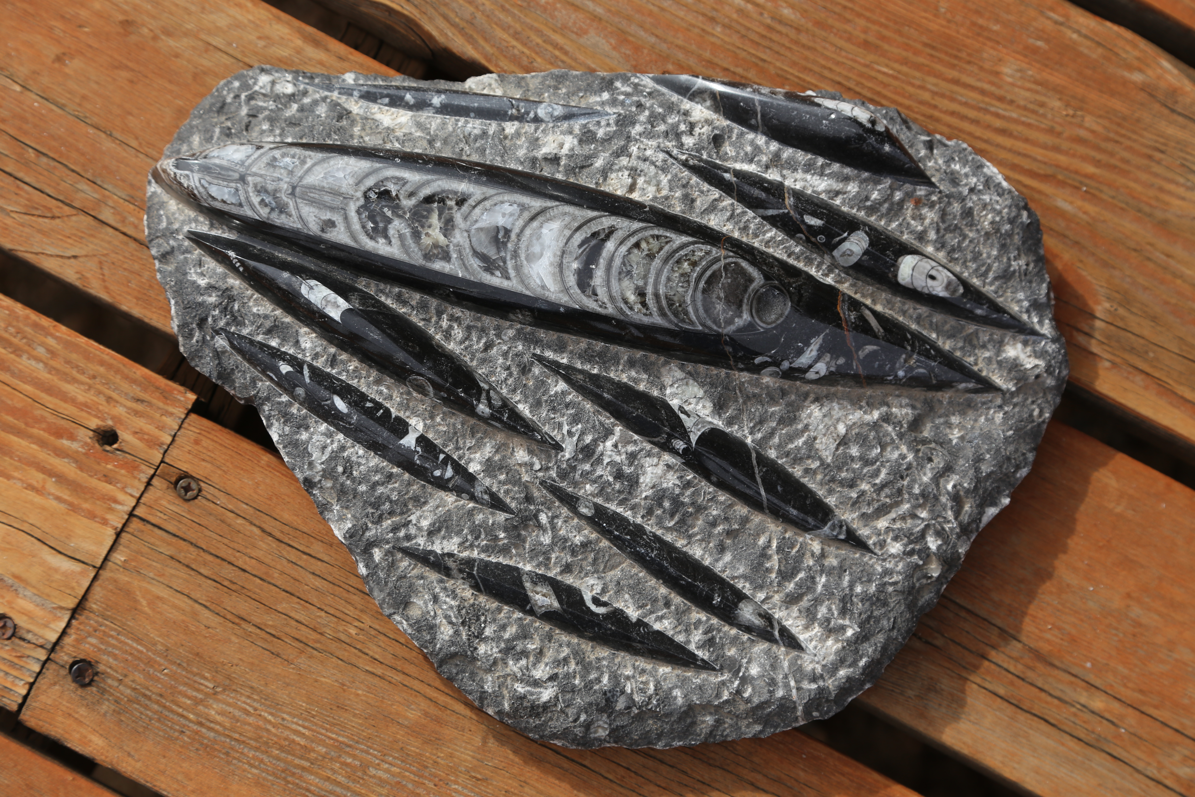
Wiki Commons User: Dcrjsr
A straight nautiloid (squid-like mollusks) found in the Middle Ordovician to Triassic aged limestone. Many nautiloids, like orthoceras, were marine predators in their day. The straight, conical shell was made up of connected chambers. The curves of the chamber walls of their shells can often be seen in their fossils.

Palaeochiropteryx
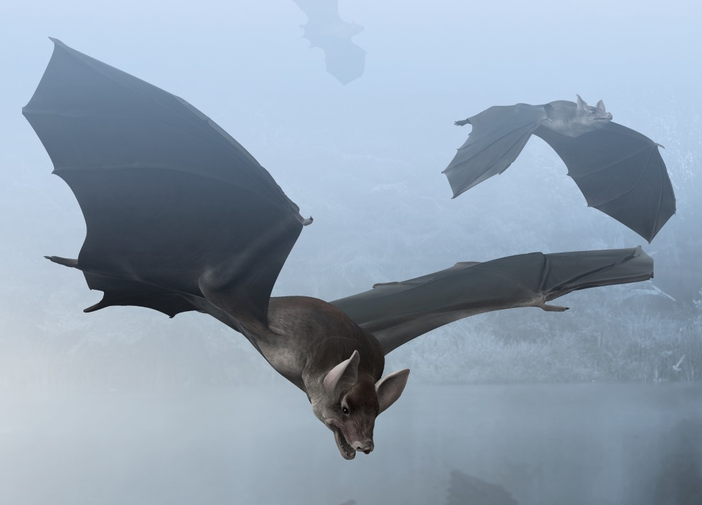
  - Wiki Commons User: Obsidian Soul
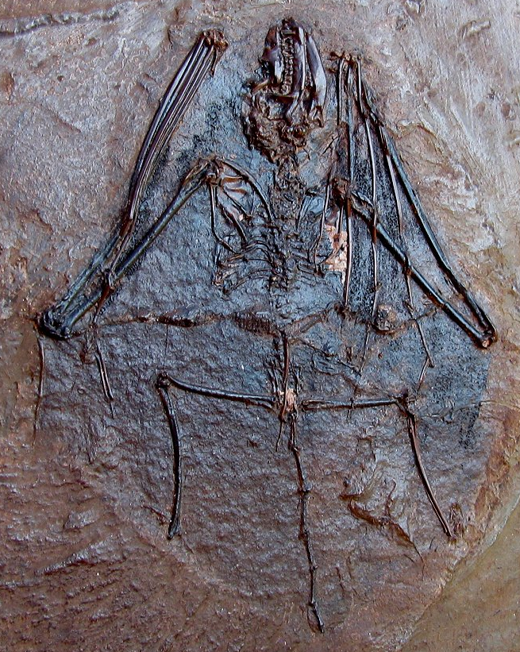
  - Wiki Commons User: Tommy from Arad
Palaechiropteryx is one of the earliest bats known from the Middle Eocene Period around 48 million years ago. The digits (or fingers) of its hands were extremely elongated and connected by a membrane of skin. These specially adapted “hands” created wings so it could fly. The teeth of palaechiropteryx show that it likely hunted insects. Fossil evidence shows that this ancient bat was also nocturnal and could echolocate like its modern relatives.

Paradoxides
  - Wiki Commons User: Futureman1199 (cropped)
Paradoxides is a large trilobite (up to 20 inches long) from the Cambrian Period between 542 million to 488 million years ago. Trilobites are arthropods (a group that includes spiders, insects, and crabs) that went extinct around 251 million years ago. Fifteen distinct segments make up the thorax of paradoxides. Each segment has ribs or spines that narrow to a point. Paradoxides has curved eyes on each side of the “glabella” (the middle part of the head).

Pterodactylus
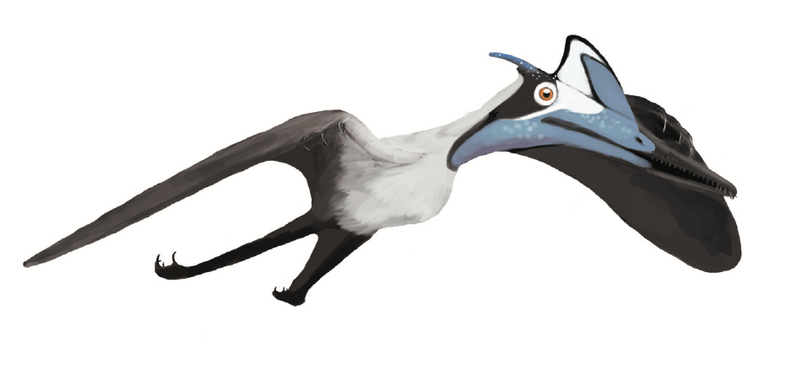
  - Matthew Martyniuk
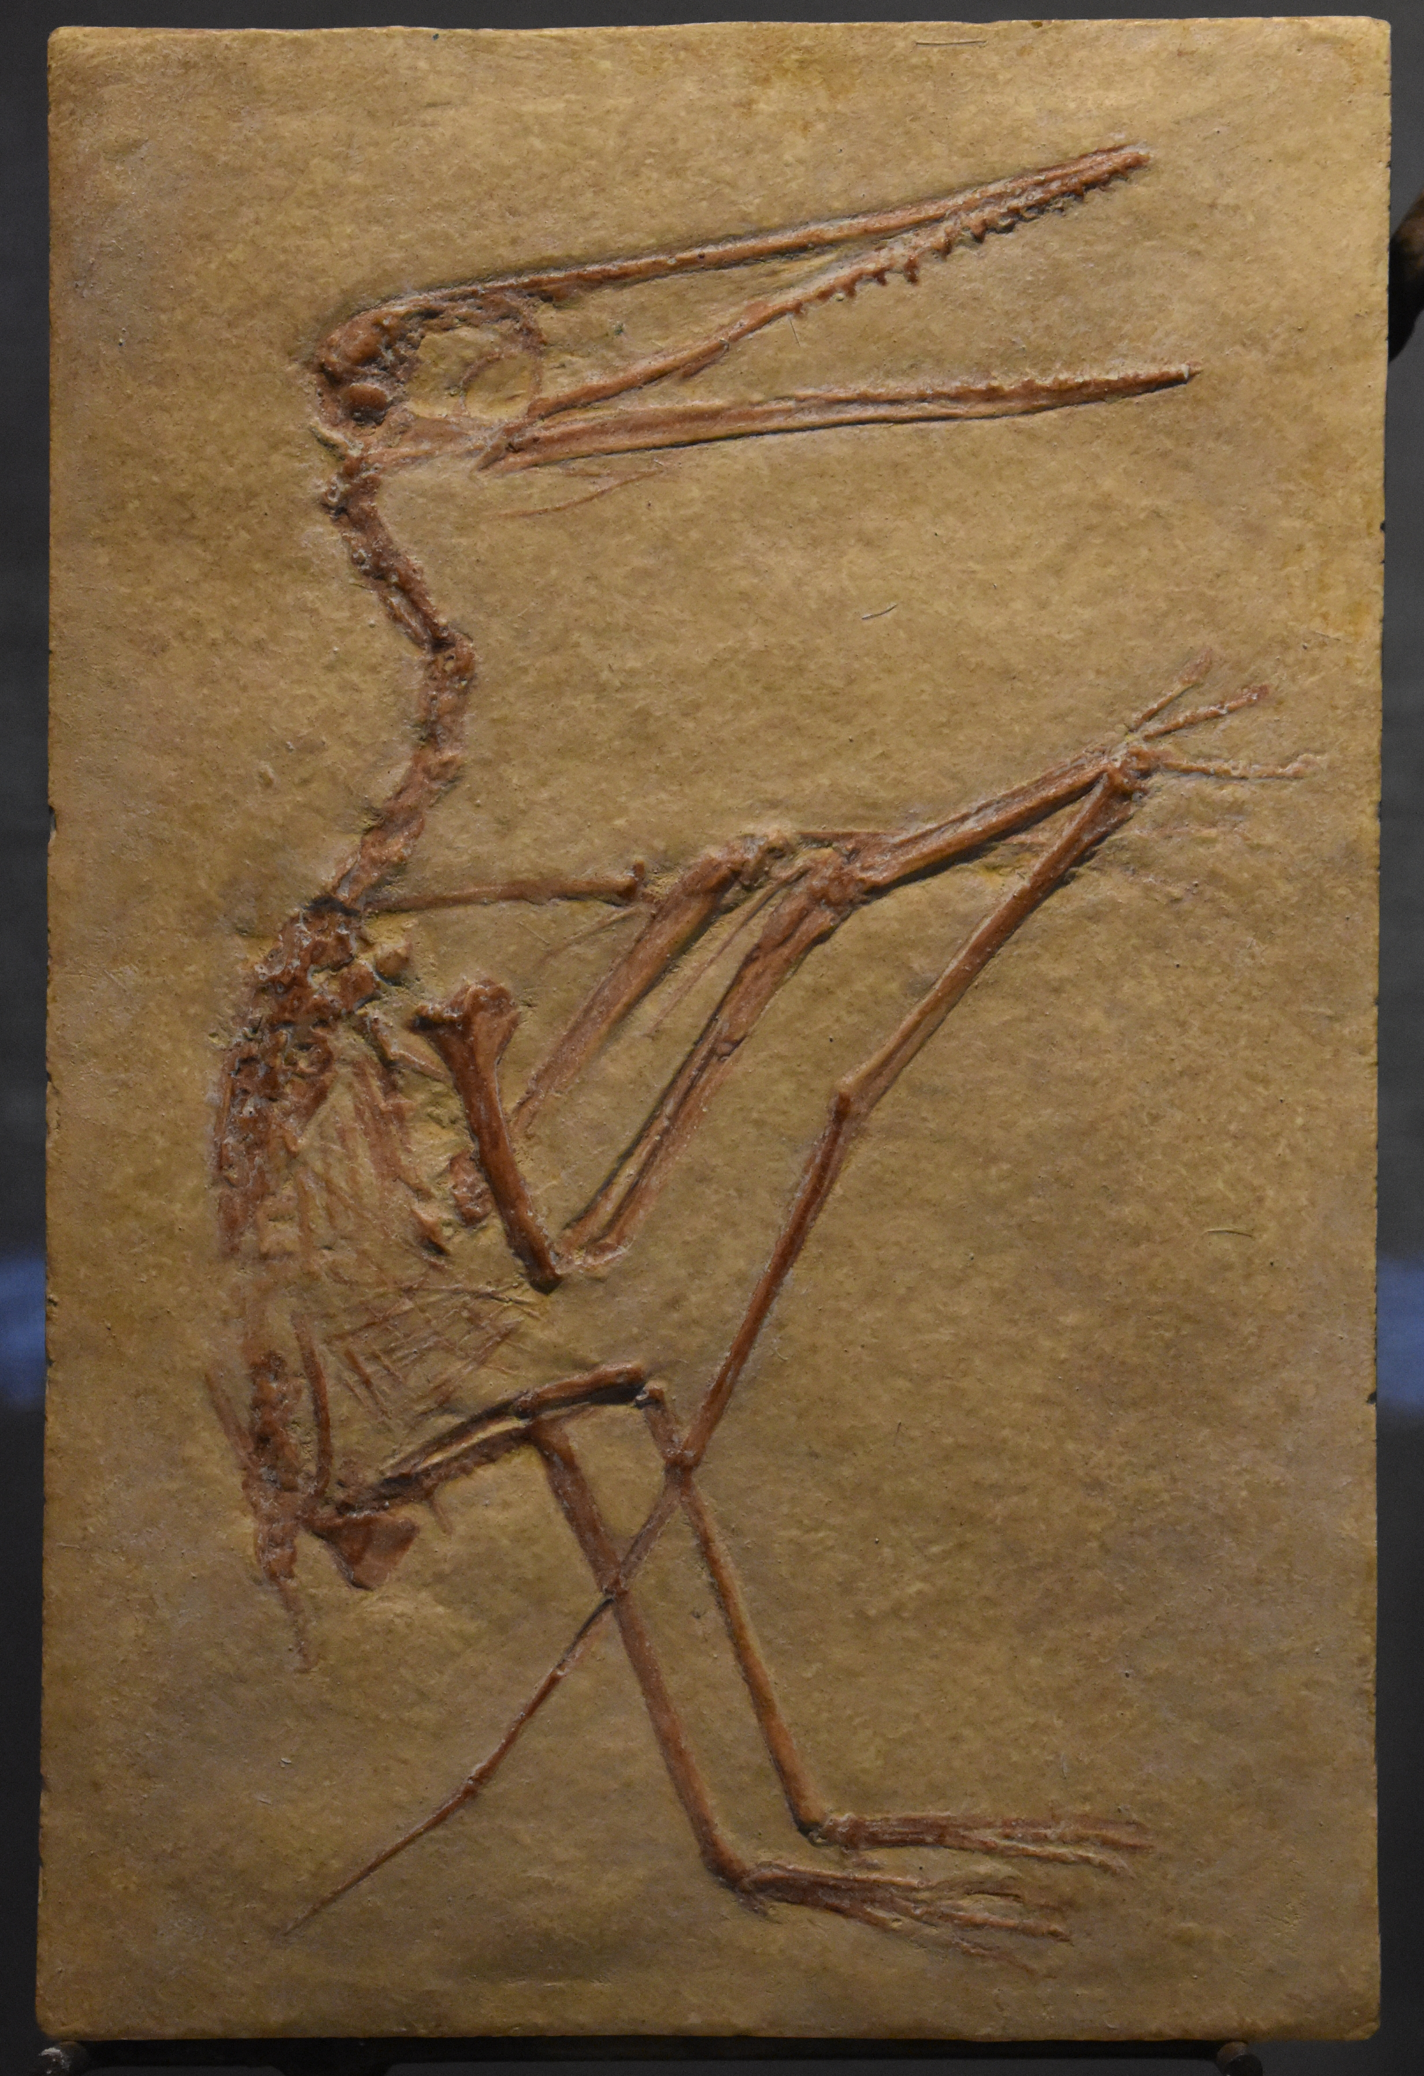
  - Pterodactylus kochi
Pterodactylus was a flying reptile from the Jurassic Period about 150 million to 148 million years ago. The fourth finger of each hand was extremely elongated to support the membrane of the wings to fly. Its tail was very short and the head was elongated with slender jaws. Pterodactylus likely ate fish and small animals.

Stromatolites
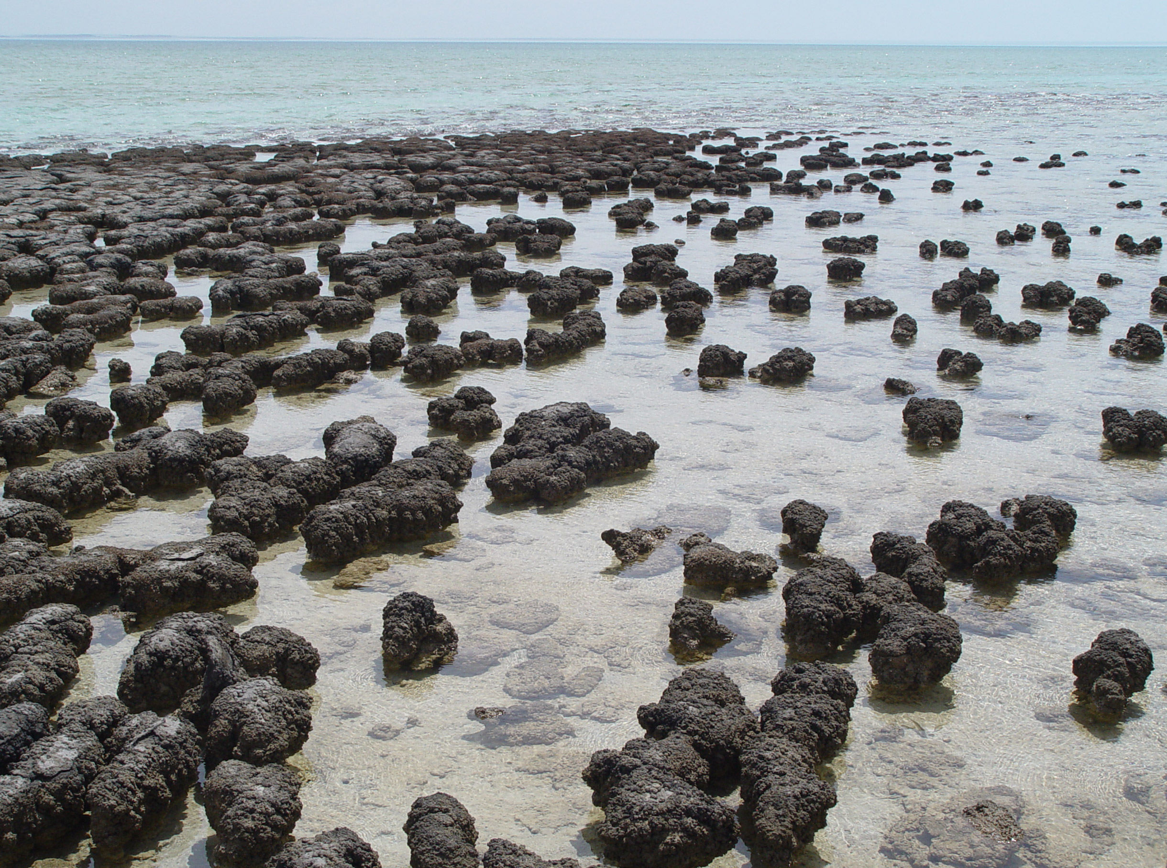
  - Paul Harrison
Stromatolites were among the first life forms to appear on Earth around 3.5 billion years ago in the Precambrian. There are some still growing today in the Quaternary. You can see them in shallow seas like at Shark Bay in Australia. Stromatolites are formed by mat-like layers of algae (single celled organisms). Alternating dark and light layers are made by sediment being washed in and trapped during storms and limestone being deposited by the algae.

Temnospondyl
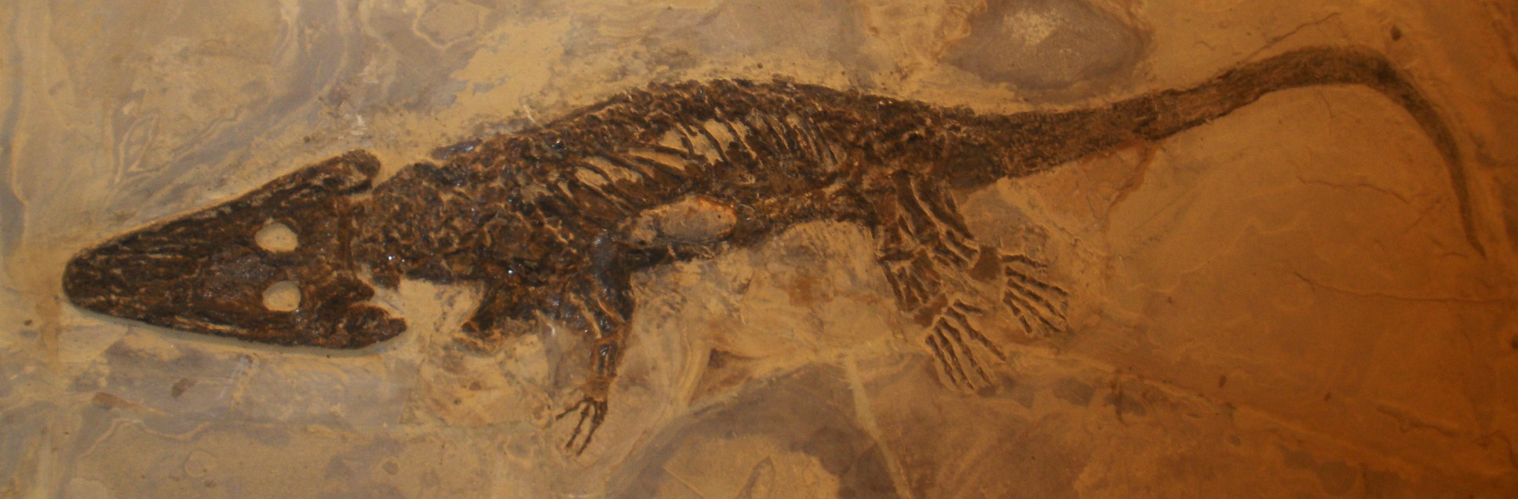
  - Wiki Commons User: Ghedoghedo
Temnospondyls are group of tertapods, four limbed vertebrates, which first appeared in the Carboniferous Period. Temnospondyls are thought to be a very early type of amphibian. They were adapted to a variety of environments. Some were semi-aquatic amphibians. Others moved onto land with their strong legs.

Triceratops
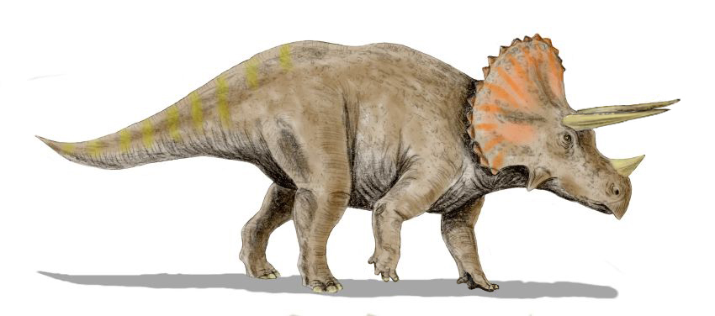
  - Created by Wiki Commons User: Nobu Tamura, modified by User: MathKnight
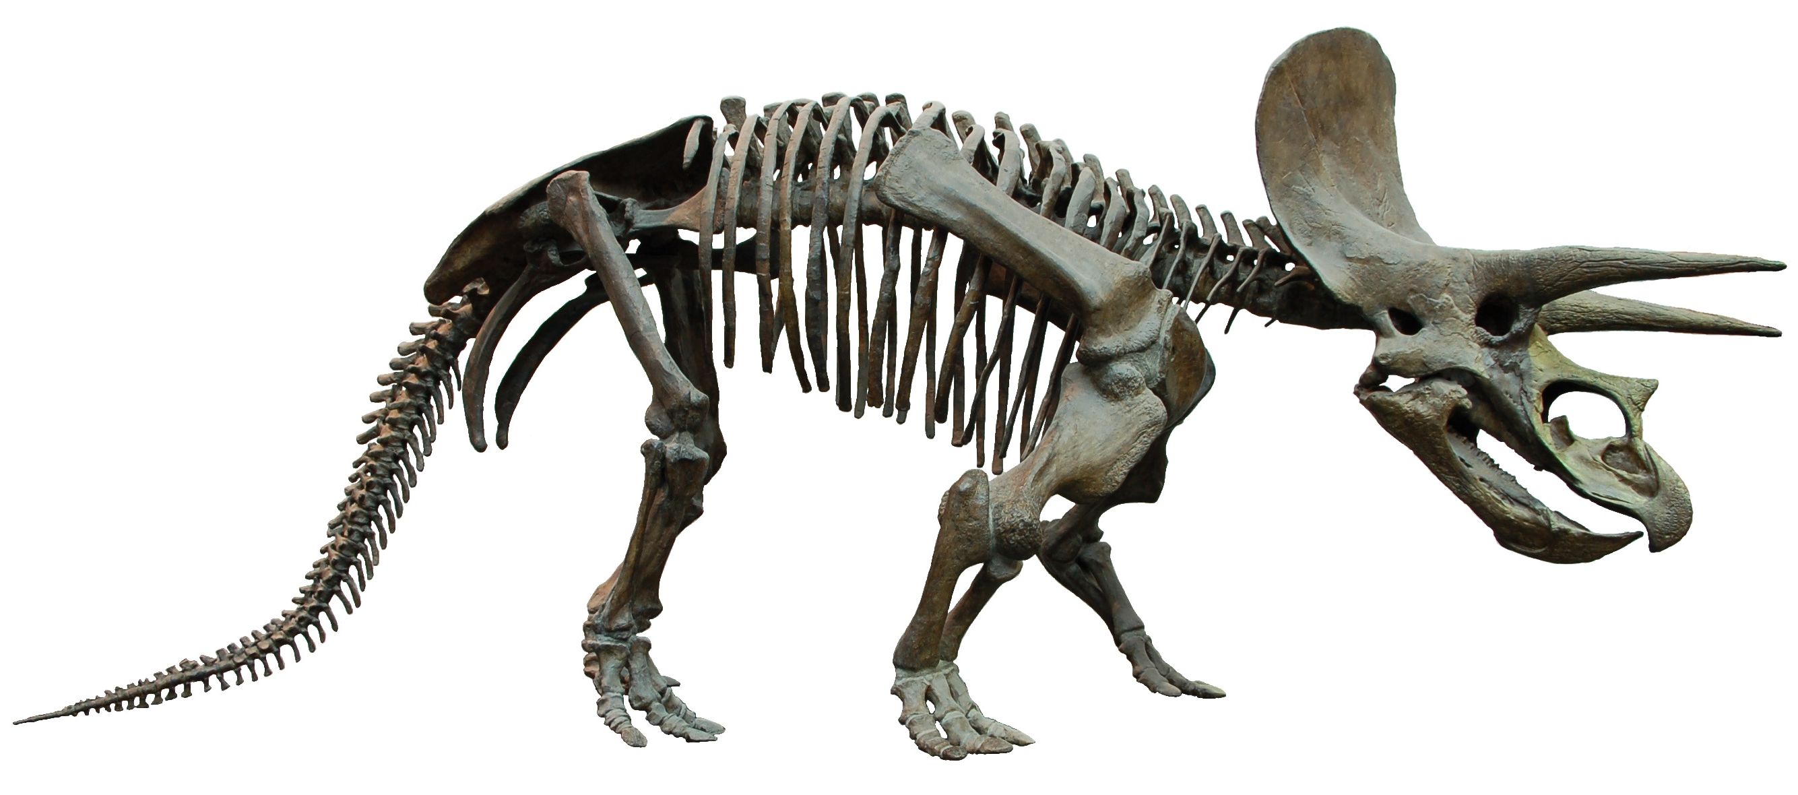
  - Wiki Commons User: EvaK
Triceratops is a famous dinosaur that lived in the Late Cretaceous Period from 145 million to 65 million years ago. It is known for having three horns in its face and a large bony frill on the back of its skull. Its powerful beak was great for cutting and chewing vegetation that it ate.

